

*Group-3*

*Capstone Project – Report*

***ShopForHome***

**TEAM MEMBERS:**

KOPPULA DEEPIKA

POORVI SHRIVAS

RAJ KUMAR

SHREYA GANGOPADHYAY

SUGANDHA RAVINDRA DHANAWADE

# ACKNOWLEDGEMENT

We have taken a lot of effort into this project. However, completing this project would not have been possible without the support and guidance of a lot of individuals. We would like to extend our sincere thanks to all of them.

We are highly indebted to Mr. **Mr. PARTH SHUKLA** for their guidance and supervision. We would like to thank him for providing the necessary information and resources for this project.

We would like to express our gratitude towards our parents & our friends for their kind cooperation and encouragement which help us a lot in completing this project.

Our thanks and appreciations also go to our colleague in developing the project. Thank you to all the people who have willingly helped us out with their abilities.

**TEAM MEMBERS:**

KOPPULA DEEPIKA

POORVI SHRIVAS

RAJ KUMAR

SHREYA GANGOPADHYAY

SUGANDHA RAVINDRA DHANAWADE

# Abstract

E-commerce is a business process over a computer network. A person sitting in a chair in front of a computer can access all the features of the Internet to buy and sell products. Unlike traditional commerce, which is physically done by human effort to obtain a product, e-commerce has made it easier for people to reduce manual labour and save time. Although e-commerce, which began in the early 1990s, has made great strides in the computer world, it has been security that has hindered the growth of e-commerce.

Security is a challenge facing e-commerce today, and there are still many advances in security. The main advantage of e-commerce over traditional commerce is the user can browse online shops, compare prices, and order merchandise sitting at home on their PC. An online shopping system that permits a customer to submit online orders for items and/or services from a store that serves both walk-in customers and online customers.

The online shopping system presents an online display of an order cut off time and an associated delivery window for items selected by the customer. The system accepts the customer`s submission of a purchase order for the item in response to a time of submission being before the order cut off time. The online shopping system does not settle with a credit supplier of the customer until the item selected by the customer is picked from inventory but before it is delivered. Therefore, customers can go online and change their orders.

# Introduction

Online shopping is a form of e-commerce that allows consumers to purchase goods and services directly from sellers over the Internet using a web browser or mobile app. Consumers are interested in products by visiting the retailer's website directly or by browsing alternative suppliers using a shopping search engine that displays the availability and price of the same product at different e-retailers. As of 2020, customers will be able to shop online using a variety of computers and devices, including desktop computers, laptops, tablets and smartphones.

Online stores are reminiscent of the physical analogy of buying a product or service at a regular retail store or mall. This process is known as B2C (Business-to-Consumer) online shopping. If an online store is set up so that a company can make purchases from other companies, the process is called business-to-business (B2B) online shopping. In a typical online store, customers can browse the company's various products and services, and view product photos and images along with information about product specifications, features, and prices.

Online stores usually allow buyers to use the "search feature" to find a particular model, brand, or item. Online customers must have internet access and a valid payment method to complete the transaction. Services such as credit cards, Interact-enabled debit cards, or PayPal. For physical items (such as paperbacks and clothing), the e-tailer ships the item to the customer.

For digital products such as digital audio files for songs and software, e-tailers typically send the files to customers over the Internet. The largest of these online retailers are Alibaba Amazon.com and eBay.

# Project definition

ShopForHome is a popular Store in the market for shopping the home décor stuff. Due to Covid 19 all the offline shopping stopped. So, the store wants to move to the online platforms and wants their own web application.

There are 2 users on the application: -

1. User
2. Admin

User Stories –

1. As a user I should be able to login, Logout and Register into the application.
2. As a user I should be able to see the products in different categories.
3. As a user I should be able to sort the products.
4. As a user I should be able to add the products into the shopping cart.
5. As a user I should be able to increase or decrease the quantity added in the cart.
6. As a user I should be able to add “n” number of products in the cart.
7. As a user I should be able to get the Wishlist option where I can add those products which I want but don’t want to order now.
8. As a user I should get different discount coupons.

Admin Stories –

1. As an Admin I should be able to login, Logout and Register into the application.
2. As an Admin I should be able to perform CRUD on Users.
3. As an Admin I should be able to Perform CRUD on the products.
4. As an Admin I should be able to get bulk upload option to upload a csv for products details
5. As an Admin I should be able to get the stocks.
6. As an Admin I should be able to mail if any stock is less than 10.
7. As an Admin I should be able to get the sales report of a specific duration.
8. As an Admin I should be able to set the discount coupons for the specific set of users

**Technologies Used:**

**Frontend –** • *Angular*

* + *Material UI (Sweetaleat2, MatCard, MatTable etc.)*
  + *HTML, CSS*
  + *Bootstrap Grid*
  + *Font Awesome Icons*

**Backend –**

* + *Java*
  + *Spring Boot*
  + *Data JPA*
  + *Microservices*

**Security –**

* + *JWT Authentication*

**Database –**

* + *MySQL*

**Design and development environment:**

**Front-end:**

The frontend of a website describes the part that the visitor can see. It includes all displayed content that is visible to public or logged-in users. The frontend is often called the GUI (Graphical User Interface) because it is the interface that the visitors can see and use. The frontend is mainly used to display various types of content and make the user’s input available to the backend. The displayed content includes the basic structure of the website, such as the navigation. The frontend includes texts, graphics, videos, and other media.

**Html5:**

The Hypertext Markup Language or HTML is the standard markup language for documents designed to be displayed in a web browser. It can be assisted by technologies such as Cascading Style Sheets (CSS) and scripting languages such as JavaScript.

Web browsers receive HTML documents from a web server or from local storage and render the documents into multimedia web pages. HTML describes the structure of a web page semantically and originally included cues for the appearance of the document.

HTML elements are the building blocks of HTML pages. With HTML constructs, images and other objects such as interactive forms may be embedded into the rendered page. HTML provides a means to create structured documents by denoting structural semantics for text such as headings, paragraphs, lists, links, quotes, and other items. HTML elements are delineated by tags, written using angle brackets. Tags such as directly introduce content into the page. Other tags such as

surround and provide information about document text and may include other tags as subelements. Browsers do not display the HTML tags but use them to interpret the content of the page.

**CSS:**

Cascading Style Sheets (CSS) is a style sheet language used for describing the presentation of a document written in a markup language such as HTML or XML (including XML dialects such as SVG, MathML or XHTML). CSS is a cornerstone technology of the World Wide Web, alongside HTML and JavaScript. CSS is designed to enable the separation of presentation and content, including layout, colours, and fonts. This separation can improve content accessibility; provide more flexibility and control in the specification of presentation characteristics; enable multiple web pages to share formatting by specifying the relevant CSS in a separate .CSS file, which reduces complexity and repetition in the structural content; and enable the .CSS file to be cached to improve the page load speed between the pages that share the file and its formatting.

**Angular JS:**

AngularJS was a JavaScript-based open-source front-end web framework for developing singlepage applications. It was maintained mainly by Google and a community of individuals and corporations. It aimed to simplify both the development and the testing of such applications by providing a framework for client-side model–view– controller (MVC) and model–view–view model (MVVM) architectures, along with components commonly used in web applications and progressive web applications. AngularJS was used as the frontend of the MEAN stack, that consisted of MongoDB database, Express.js web application server framework, AngularJS itself (or Angular), and Node.js server runtime environment.

**Back-end:**

The backend to a website is pretty much everything the user can't see. Generally, this means the programming that generates pages that the user views, creating the "server-side" content of the site. This could be scripts, directives, databases, and other automated functions the server performs. Back-end development includes the server implementation and it more on the logical interaction of data, how it is stored, and transmitted.

**Java:**

Java is a high-level, class-based, object-oriented programming language that is designed to have as few implementation dependencies as possible. It is a general-purpose programming language intended to let programmers write once, run anywhere (WORA), meaning that compiled Java code can run on all platforms that support Java without the need to recompile. Java applications are typically compiled to bytecode that can run on any Java virtual machine (JVM) regardless of the underlying computer architecture. The syntax of Java is similar to C and C++ but has fewer low-level facilities than either of them.

The Java runtime provides dynamic capabilities (such as reflection and runtime code modification) that are typically not available in traditional compiled languages. As of 2019, Java was one of the most popular programming languages in use according to GitHub, particularly for client–server web applications, with a reported 9 million developers. Java was originally developed by James Gosling at Sun Microsystems and released in May 1995 as a core component of Sun Microsystems' Java platform.

The original and reference implementation Java compilers, virtual machines, and class libraries were originally released by Sun under proprietary licenses. As of May 2007, in compliance with the specifications of the Java Community Process, Sun had relicensed most of its Java technologies under the GPL-2.0-only license. Oracle offers its own Hotspot Java Virtual Machine, however the official reference implementation is the OpenJDK JVM which is free open-source software and used by most developers and is the default JVM for almost all Linux distributions.

**Database:**

In computing, a database is an organized collection of data stored and accessed electronically. Small databases can be stored on a file system, while large databases are hosted on computer clusters or cloud storage. The design of databases spans formal techniques and practical considerations including data modelling, efficient data representation and storage, query languages, security and privacy of sensitive data, and distributed computing issues including supporting concurrent access and fault tolerance. A database management system (DBMS) is the software that interacts with end users, applications, and the database itself to capture and analyse the data. The DBMS software additionally encompasses the core facilities provided to administer the database. The total sum of the database, the DBMS and the associated applications can be referred to as a database system. Often the term "database" is also used loosely to refer to any of the DBMS, the database system or an application associated with the database.

**MySQL:**

MySQL is a relational database management system based on the Structured Query Language, which is the popular language for accessing and managing the records in the database. MySQL is open-source and free software under the GNU license. It is supported by **Oracle Company**.

MySQL is currently the most popular database management system software used for managing the relational database. It is open-source database software, which is supported by Oracle

Company. It is fast, scalable, and easy to use database management system in comparison with Microsoft SQL Server and Oracle Database.

**Database Schema :**

**Screenshots Of Project**

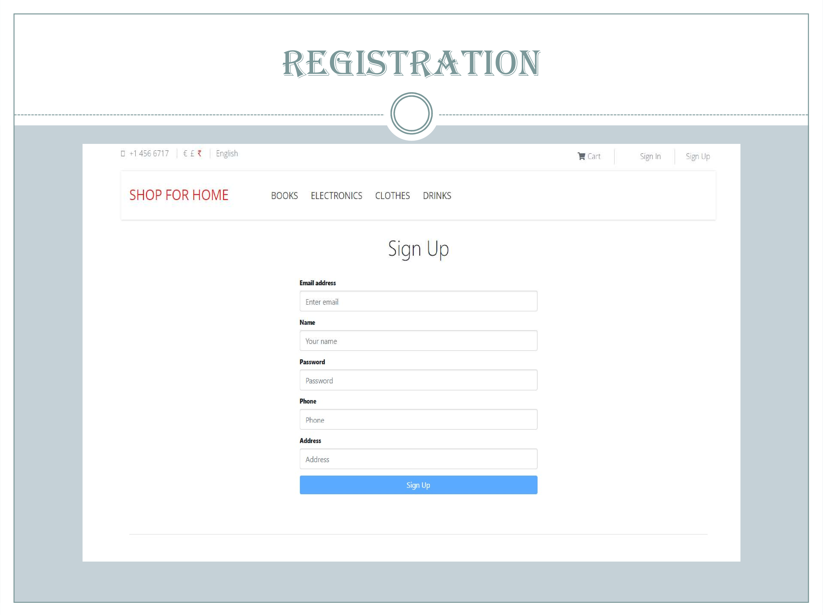

**SCREENSHOTS OF GCP DEPLOYMENT**:

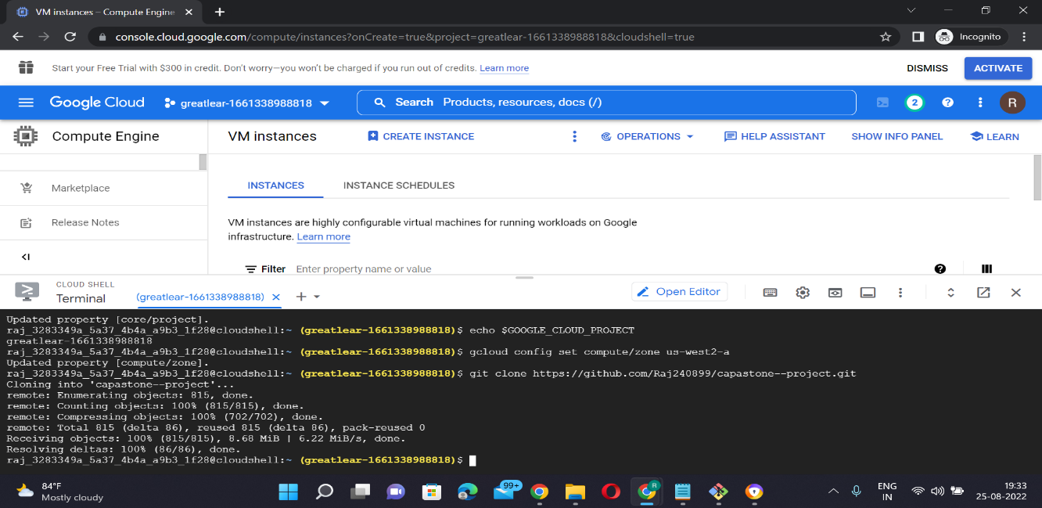

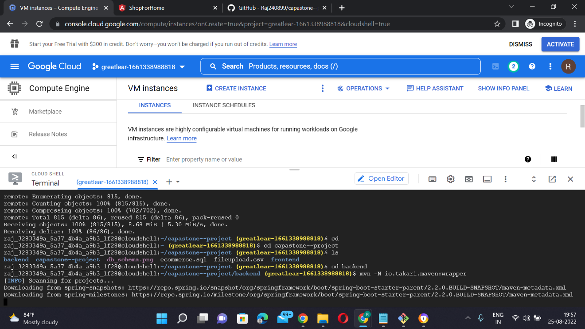

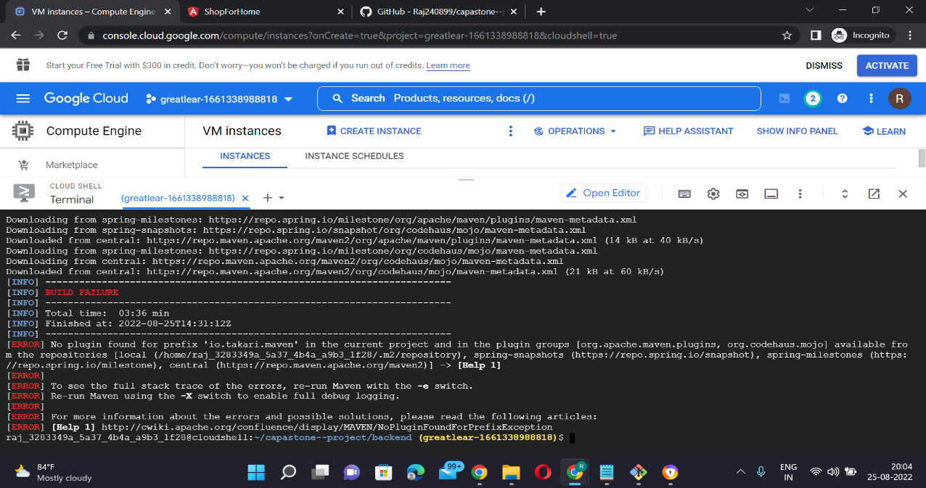

**Conclusion :**

Technology has made significant progress over the years to provide consumers a better online shopping experience and will continue to do so for years to come. With the rapid growth of products and brands, people have speculated that online shopping will overtake in-store shopping. While this has been the case in some areas, there is still demand for brick-and-mortar stores in market areas where the consumer feels more comfortable seeing and touching the product being bought. However, the availability of online shopping has produced a more educated consumer that can shop around with relative ease without having to spend a large amount of time. In exchange, online shopping has opened up doors to many small retailers that would never be in business if they had to incur the high cost of owning a brick-and-mortar store. At the end, it has been a win-win situation for both consumer and sellers.